For the game so far I only added the basics.  
  
So I added a 3d camera using this tutorial:

<https://www.youtube.com/watch?v=XT6mUlpO4fA>

And I also added a 3d movement system that I developed in roll a ball. It is similar to that in roll a ball but with a few key changes.

1. First change is the most important and it is to make the force smooth instead of a rolling or pushing force thats janky. For this I followed the tutorial  
   <https://www.youtube.com/watch?v=XT6mUlpO4fA>  
   Where he has this block of code:  
   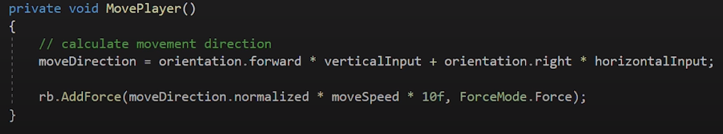
2. Second is that I want the player to only be able to move when the player is grounded. To do this I simply just added an isGrounded variable that will trigger on and off depending whether the player is on a ground surface or not.

Aside from those two I did not add alot to my game as of yet. I know I said I would add more after I finished my website. The only thing is that I still haven’t finished my website :( as of writing this atleast. I tried getting the basics done for now so I atleast have something to show. I paln on adding the grappling behavior later with step by step raycasting in order to detect collisions. Additionally I plan to make grappling hooks that are already on a surface slowly pull you in towards that direction. This will be done by a constant force vector.

I feel a behind by a little behind but I am sure that I will be able to catch up :).

(NOTE AS OF WRITING THIS GAME DOC#2 I HAVE NOT IMPLEMENTED THESE CHANGES I PROCRASTINATED TOO MUCH :( BUT I WILL IMPLEMENT THEM ON TUESDAY SO WHEN CLASS STARTS THESE CHANGES WILL BE IN PLACE !!!!)